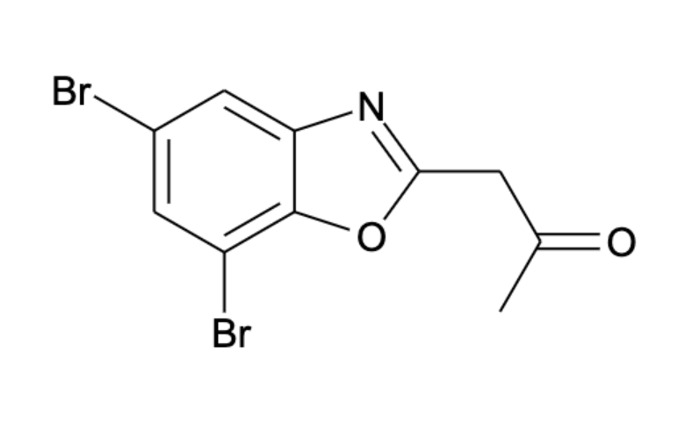

1-(5,7-dibromo-1,3-benzoxazol-2-yl)propan-2-one Ferroin

disodium 2-[2-[bis(carboxylatomethyl)azaniumyl]ethyl-(carboxylatomethyl)azaniumyl]acetate

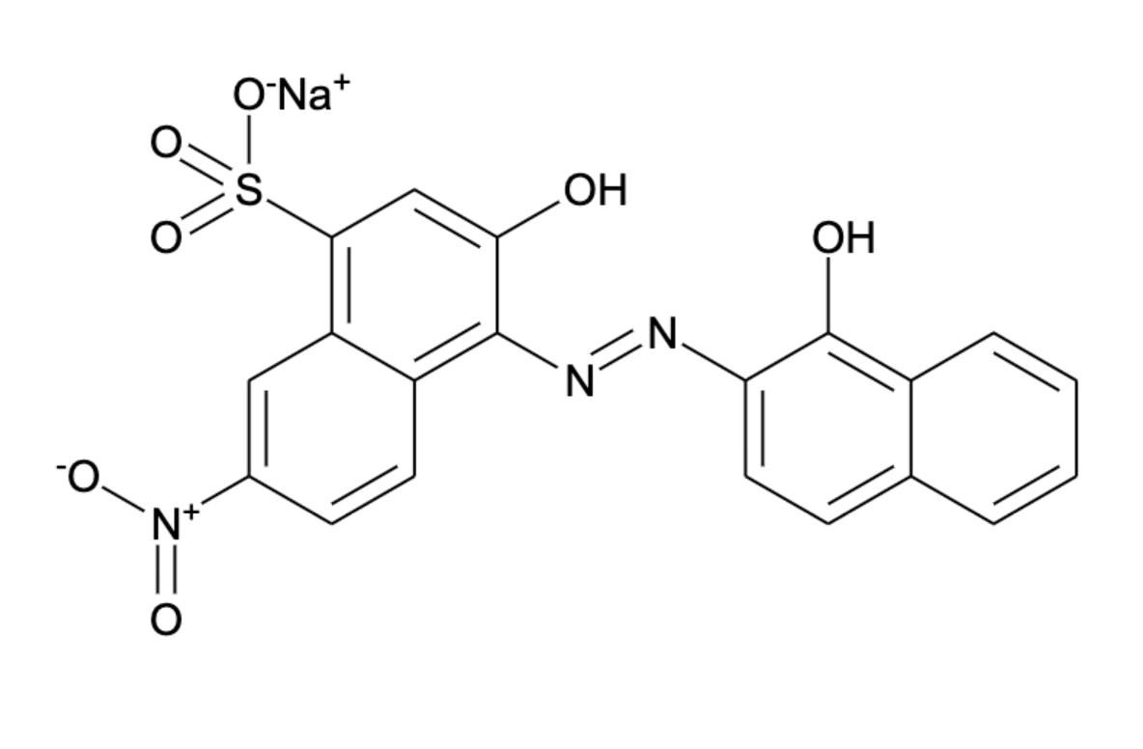

sodium 3-hydroxy-4-[(E)-(1-hydroxynaphthalen-2-yl)diazenyl]-7-nitronaphthalene-1-sulfonate polyvinyl alcohol

starch (amylose)

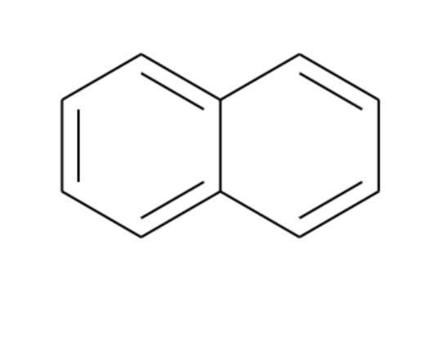

naphthalene biphenyl